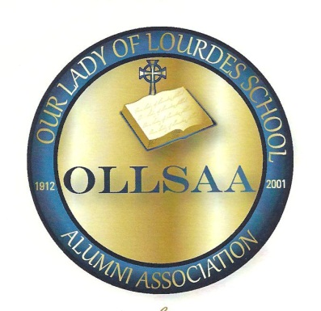

“A Legacy of Excellence in Catholic Education”

4392 Clement Drive, S.W.
Atlanta, Georgia 30331

March 1, 2015

Dear Applicant:

The Alumni Association of Our Lady of Lourdes School will present a scholarship to a 2015 graduating senior who will be attending a Catholic College or University in the fall of 2015.

Qualifications are as follow:

- 2015 High School Graduate
- Financial need
- Two Recommendations:
1 from your principal or counselor
1 from a teacher
- Minimum of a 3.0 grade point average
- A brief autobiography detailing your interest in attending a Catholic College or University and financial need.
- Completed Application

The deadline for the completed application, the two letters of recommendation and a transcript is April 13, 2015. The winner will be notified by April 25, 2015.
Thank you for your interest.

Sincerely,
Jacquelyn S. Daniel
Jacquelyn S. Daniel, Ed.D.
Chair, Scholarship Committee
MISSION To impact education by providing human and financial resources to
Potential teachers, thus shielding them from financial restraints.
2218 Bonnybrook Way SW
Atlanta, Gea 30311

Scholarship Committee
Naomi Beasley
Miltona Bryson
Jacquelyn Daniel
Jean George
Wilma Nichols
Barbara Robinson
Sheridan Rogers
Vivien Stocks
Miriam Stokes
Marcia Williams

